Name___________________________________

Quick Quiz

**Unit Rate 8**

Identify the unit rate:

1. fly 490 miles in 5 hours 2. $y=\frac{1}{3}x$

**_________ miles per hour unit rate =_________**

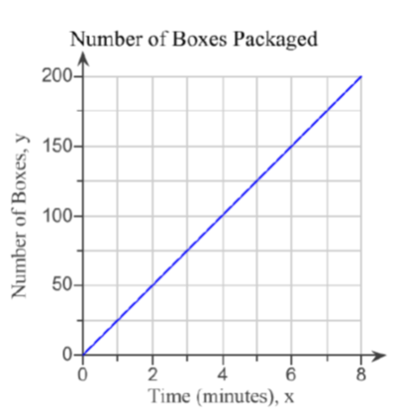

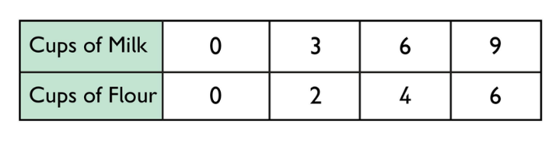3. 4.  **________**

**boxes per minutes**

**_________ cups flour per cup of milk**

____________________________________________________________________________

Corrections

**Unit Rate 8**

Identify the unit rate:

1. fly 490 miles in 5 hours 2.

**_________ miles per hour unit rate =_________**



3. 4.  **________**

**boxes per minutes**

**_________ cups flour per cup of milk**